# Component 3 (Project)

## Contents

Component 3 (Project) 1

Contents 2

Analysis 3

Project Identification 3

Summary of my project 3

Characters 3

Sounds 3

Sprites 3

Computational Methods 4

Thinking Abstractly 4

Thinking Ahead 4

Thinking Procedurally 4

Thinking Logically 4

Thinking Concurrently 5

Stakeholders 5

Research 5

Moto X3M (from www.coolmathgames.com) 5

The Chrome Dino Game (Build into The Chromium Project) 6

Controls 7

Stakeholder research 7

1. Rate how engaging the Dino Game was 8

2. Explain your rating to the previous question 8

3. Rate how engaging Moto 3XM was 9

9

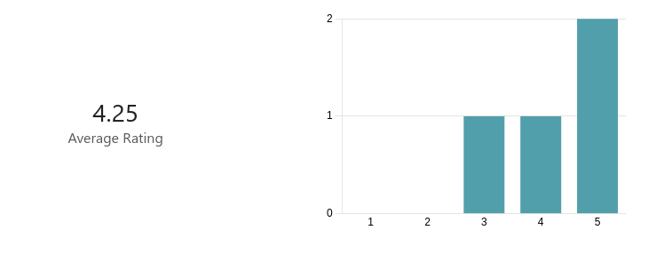

4. Explain your rating to the previous question 9

5. Rate how engaging Mountain Biking 1.0 was 10

6. Explain your rating to the previous question 10

7. Rate the controls in the Dino Game 10

8. Explain your rating to the previous question 10

9. Rate the controls in Moto 3XM 11

10. Explain your rating to the previous question 11

11. Rate the controls in Mountain Biking 1.0 12

12

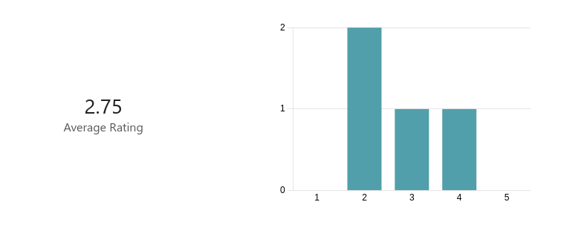

12. Explain your rating to the previous question 12

13. Rate the aesthetics of the Dino Game 12

12

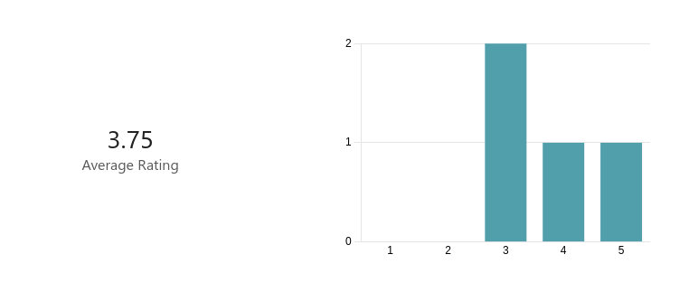

14. Explain your rating to the previous question 12

15. Rate the aesthetics of Moto 3XM 13

16. Explain your rating to the previous question 13

17. Rate the aesthetics of Mountain Biking 1.0 14

14

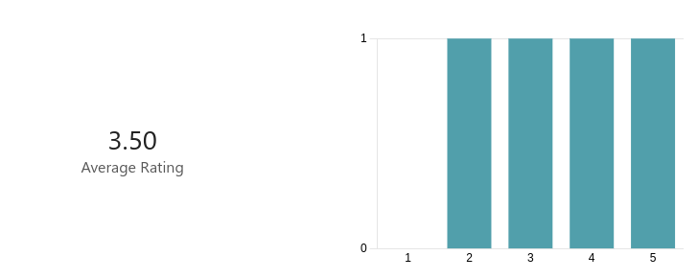

18. Explain your rating to the previous question 14

19. Did you like the infinitely scrolling nature of the Dino Game and Moto 3XM? 15

15

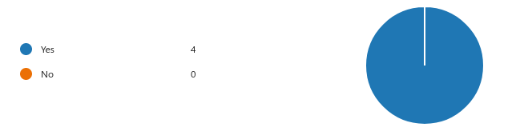

20. Rank the games on how much you liked them overall 15

15

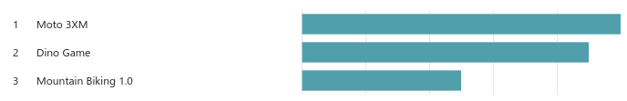

21. Explain your ranking 15

22. Name 3 things you liked about the Dino Game 15

23. Name 3 things you liked about Moto 3XM 16

24. Name 3 things you liked about Mountain Biking 1.0 16

## Analysis

## Project Identification

### Summary of my project

The project that I intend to complete is an infinite running game. Games like these can be played by a single player at a time. The player navigates through the game using the space key to jump navigating along the infinitely scrolling level manoeuvring themselves around a constantly changing environment. A high-score is calculated by the distance that the player completed plus the number of rewards that the player collects. This high score can then be compared with others scores to enable competition between players. The game-play gets progressively harder with a higher speeds and potentially harder level design.

I aim to make this game accessible, allowing anybody to play regardless of age, ability, and income, etc. Although many infinite running games do exist there is a gap in the market for accessible games in this genre

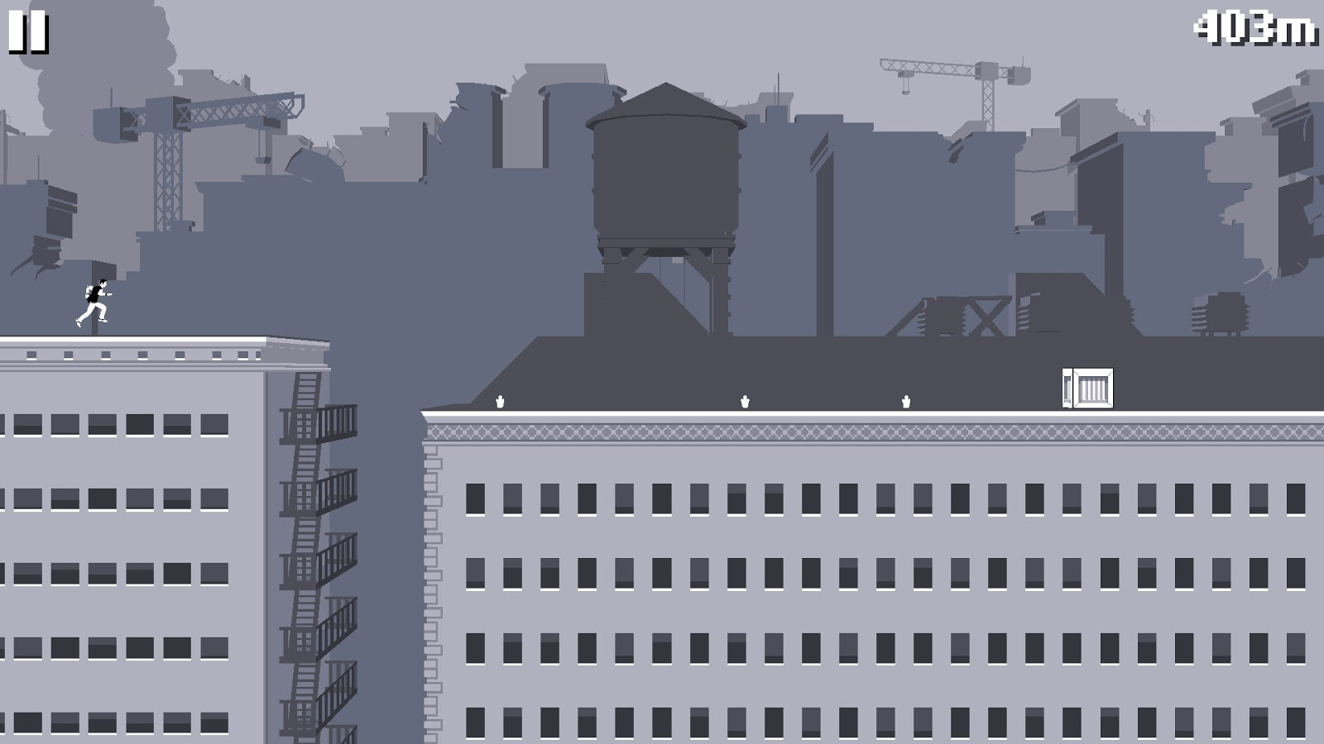

### Characters

The game includes a single playing character. This character is controlled by the player. To play the game this character is moved through the levels. If the player comes into contact with the walls or any other dangerous game object the score is reset and the game begins from scratch.

### Sounds

I want the game to have an arcade like feel. Therefore I will implement simple sounds to create this impression. I will have a theme tune that plays continuously, speeding up as the game gets faster, this will increase the adrenaline response of the player.

### Sprites

Much like my inspiration I aim to use pixel art for my sprites. This will add to the arcade feel of the game. Although the monochrome aspect of the original game is visually interesting I believe that sprites with a wide range of vibrant colours will be more entertaining for younger audiences.

## Computational Methods

The game is suitable for a digital solution as it has principles / physics that can be easily enforced by simple algorithms. A non-computational version of my project would lack immersion as in game objects would not be able to be individually controlled. Due to the fundamental lack of refreshing controllable graphics in non-computational situations it is imperative that my program uses a computer.

Another benefit of creating this game computationally is the potential for networked gameplay. In a future version of this game networked gameplay would allow players to play the game socially, creating an element of competition.

### Thinking Abstractly

In order to simplify the gameplay and the production of the project many unnecessary aspects of reality are discarded. The main example of this is the 2D nature of the game, although in reality the world is seen in 3D a 3D game would overcomplicate the design / ease of gameplay. Another example of abstraction in my design process is the blocky graphics used, the need to make the game photo-realistic is diminished allowing me to focus on creating an engaging playing experience.

### Thinking Ahead

My games gameplay will be controlled using the space bar (To Jump) / arrow keys (^:To jump).

In order to navigate through the menu screens / settings and to pause the game a mouse cursor will be used.

In the eventuality that I port my game onto mobile platforms tapping will allow the player to jump.

### Thinking Procedurally

I will make use of object oriented programming in order to maximise efficiency of my program. All moving objects will share a class with more specific sub classes being employed for each specific character.

I will also break my program down into subroutines. This will help to increase the efficiency of the program by decreasing the amount of reused code.

### Thinking Logically

For collision detection the program will continuously check to ensure that the character hasn't collided with the platforms. When the player collides with a in game object a decision should be made on what the necessary response is.

### Thinking Concurrently

The program will use event driven programming meaning that when the user triggers an event code will be executed. This is a form of parallel processing.

## Stakeholders

The target audience for my game are young people that play computer games casually. I want my game to be accessible to everybody regardless of age, computer literacy, and ability. As the game uses simple assets I expect the game to appeal especially to younger audiences but to also be visually interesting for older players, I have chosen an array of people from all walks of life to provide feedback on my project throughout the design process.

I will use a range of named and unnamed stakeholders in order to collate a wide-range of opinions on how best to implement the features of my game. My named stakeholders include: Iustin Tamasanu (A Computer Science Student that enjoys playing computer games casually), Esme (A palliative paediatric physiotherapist), and Dora Turner (A young occasional computer gamer that enjoys simple games). I will collect regular feedback from these named stakeholders while sending out opinion polls to collect data from a wider range of my target audience.

## Research

In order to develop my ideas more thoroughly I will look into four similar games made by other developers. This will help me decide what features I want to include in this game and how best to implement them.

### Moto X3M (from [www.coolmathgames.com](http://www.coolmathgames.com))

This fast paced online 2d driving game provides an immersive experience with its bold graphics and clever controls. The user uses the arrow keys to control the motorbikes speed and tilt in order to navigate through the constantly changing terrain, this provides great control over the bike throughout the game. The game ends when the users body touches the course, this is animated through a fireball explosion, insinuating a crash.

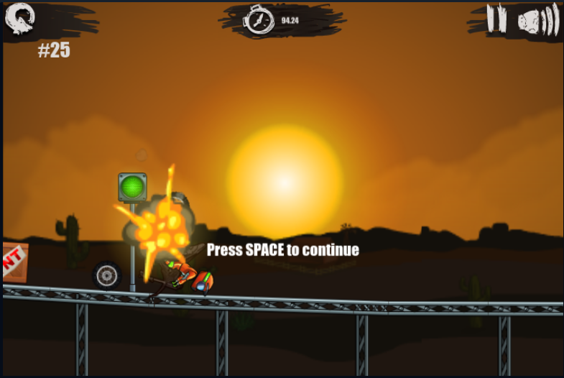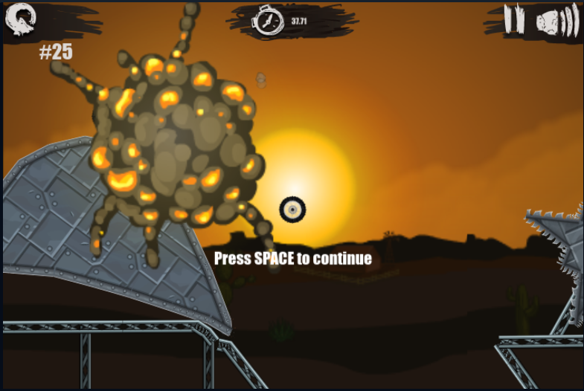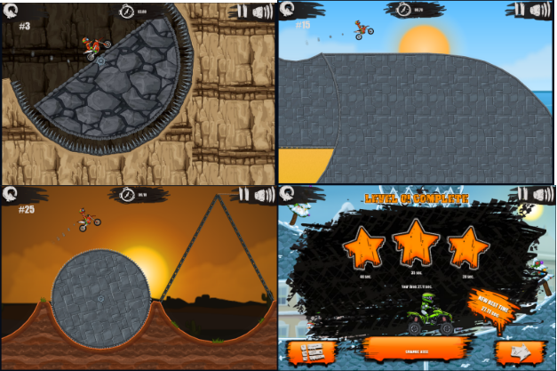

The levels become more difficult as the game is played through, with more complex level design. This provides a good feeling of progression however most of the levels can be passed with little skill.

The aim of the game is to complete the levels as quickly as possible, a star based scoring system is used to quantify the speed of the level completion. Many players enjoy speed-running the game with a record completion time of 13 minutes and 11 seconds.

Time deductions are offered when players flip the bike (0.5 sec for 1 flip, 1 sec for 2 flips, ect). This provides an interesting high risk / high reward aspect to the game.

Although I enjoy playing this game, I am aiming to create a simpler game aesthetically. I want my game to be easily accessible to all regardless of ability and in order to achieve this my game should use simple controls as some audiences may find the multiple keyed controls hard to use.

### The Chrome Dino Game (Build into The Chromium Project)

The Chrome Dino game is a simple 2d game. The user navigates through a desert environment by jumping over cactus / other objects as the game speeds up / more objects to avoid are added.

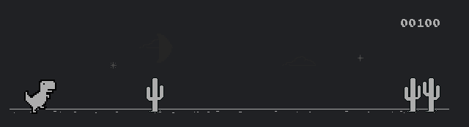

#### Controls

For more experienced gamers the controls may seem limited, the space bar is the main control (Allowing the dinosaur to jump), however this is perfect for people with reduced coordination such as young children, elderly people, and people with coordination difficulties. I like the idea of implementing a similar control layout in order to maximise accessibility.

#### Competition and High Scores

The dino game has a high score system base on how far through the game you progress. Although this is a simple implementation i like how it is easy to compare against other players. The game doesn't have any built in multiplayer / competition features however as these scores are an objective measure of a players skill level they can be shared and compared easily. An indicator showing the high score along with the current score is found in the top right hand side of the screen.

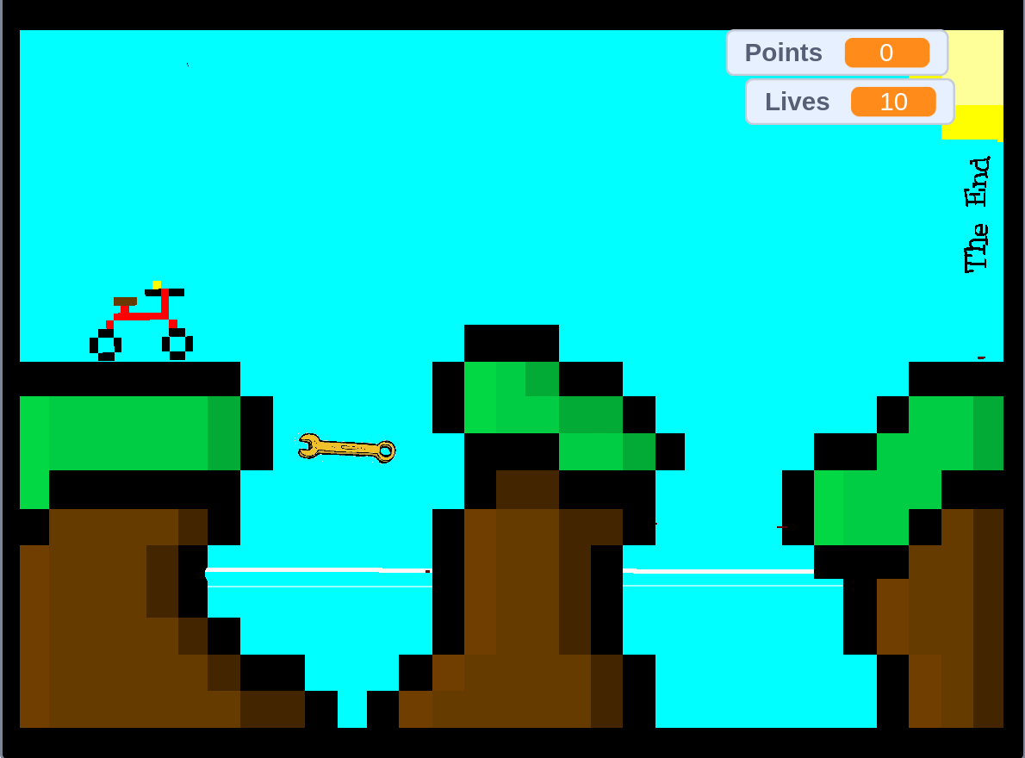

## Stakeholder research

I gave my stakeholders the 3 games that are similar to my proposed project and already on the market.

I asked them to rate the game from multiple different standpoints. Including the controls, how engaging the game was as a whole, and how much they enjoyed the visuals / sound effects.

#### Rate how engaging the Dino Game was

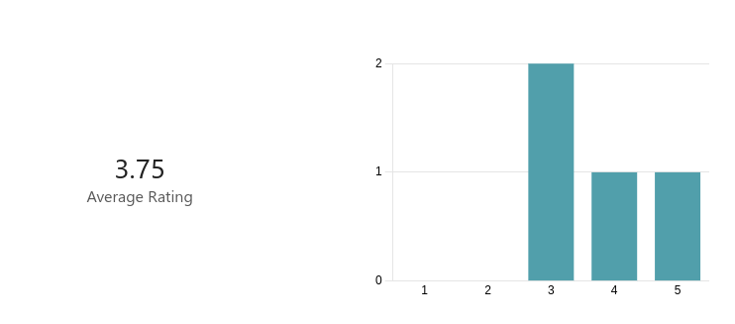

#### 2. Explain your rating to the previous question

|  |  |
| --- | --- |
| 1 | Boring graphics. Game gets repetitive overtime |
| 2 | I was instantly bored by the graphics. I love how it gets faster so its harder. |
| 3 | The intention of the game is simple entertainment with an infinite scroller. It isn't meant to have any progression, however I would enjoy this game more for it provided some customisation. An example may be the mobile game Dune!, although game mechanics are different, you unlock different background and different skins. Competition to defeat your and other people's high scores is definitely the most engaging about this game. |
| 4 | Although the game was simple the way the level of difficulty slowly increased kept me engaged for long periods of time |

Analysis: From this question I have come to the conclusion that my stakeholders like the simple nature of the game despite the fact it might seem initially too basic to allow for long play times.

To make the game more engaging i should add a way for players to easily compete by sharing their scores as well as achievements for reaching high scores.

To make the game less boring for more experienced players i will also implement a checkpoint system allowing players to start at a position that is challenging regardless of their skill level.

#### 3. Rate how engaging Moto 3XM was

### 



#### 4. Explain your rating to the previous question

|  |  |
| --- | --- |
| 1 | Exiting fast paced game. The difficulty should increase more overtime to maintain engagement. |
| 2 | I dont like the difficulty progression |
| 3 | The game had progression and and interactive environment with a variety of challenges which are built very robust. The animations are great and overall the game is very playable. |
| 4 | I love the visuals. Game play was fluid and fun. |

From these responses I have determined that my stakeholders desire a game with fluid animations however it is important that these animations can be controlled by the user and disabled if they become too visually distracting.

The stakeholders thought that although the game did have some progression the majority of stake holders would like to see a wider range of difficulties (both easier and more complex).

#### 5. Rate how engaging Mountain Biking 1.0 was

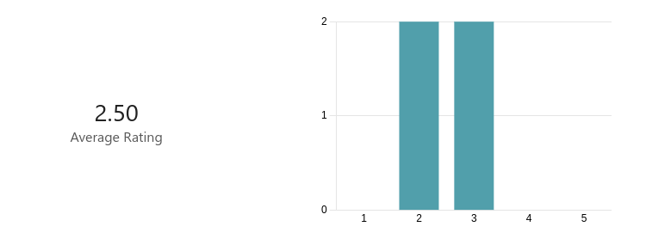

#### 6. Explain your rating to the previous question

|  |  |
| --- | --- |
| 1 | Enjoyable but due to the lack of scrolling the game feels clunky. |
| 2 | Its far too easy |
| 3 | The game is extremely simple with no GUI and introduces some game mechanics which are very strange. There very little animation. For example, I cannot use numbers and arrow keys on my 60% keyboard. I do however believe the game has potential with its blocky aesthetics, which are fairly consistent throughout the game. |
| 4 | The visuals were lacking in quality. Overall the game seemed unpolished. |

From this question i have discovered that my game should be a smooth infinite scoller without individual levels. My project should also have a well designed gui to allow for custimisable settings.

#### 7. Rate the controls in the Dino Game

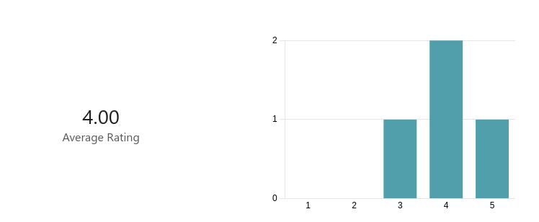

#### 8. Explain your rating to the previous question

|  |  |
| --- | --- |
| 1 | Easy to understand. Limited control. |
| 2 | Easy but boring |
| 3 | It may be as simple as pressing space. I'm giving it four stars as it is extremely responsive and the jump height depends on the duration of time the user has pressed space for which is very nice, as you want to press space for longer if you have to clear a high jump and press space shorter if you have too consecutively jump quickly. |
| 4 | Great for use one handed (I have a broken wrist). Really accessible. |

Although some users found the controls boring they are simple and accsesable. I am planning to implement a dino style control layout before adding more granular control later down the line

#### 9. Rate the controls in Moto 3XM

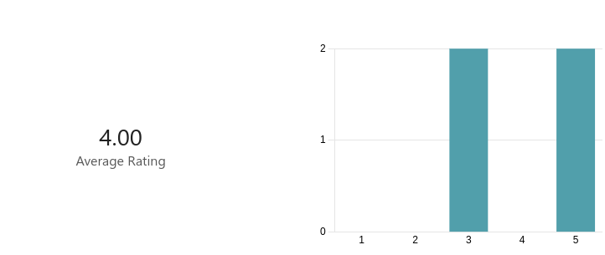

#### 10. Explain your rating to the previous question

|  |  |
| --- | --- |
| 1 | Great life like control. |
| 2 | Easy and fun |
| 3 | Controls allow me to use WASD which I love. I have full control of the motorbike to turn it how I like which makes the controls of this game satisfactory. |
| 4 | Much more control than the dino game however this comes at the cost the adaptability of the controls. |

#### 11. Rate the controls in Mountain Biking 1.0

#### 



#### 12. Explain your rating to the previous question

|  |  |
| --- | --- |
| 1 | Easy to controll however it lacks life like movement |
| 2 | Unrealistic |
| 3 | I cannot use WASD and using arrow keys on my keyboard is extremely uncomfortable. Jumping and moving is responsive. |
| 4 | Poor. Unlifelike. Suffers from the same problems as Moto 3XM without bring anything more to the table. |

#### 13. Rate the aesthetics of the Dino Game

#### 



#### 14. Explain your rating to the previous question

|  |  |
| --- | --- |
| 1 | Interesting on the first play. Due to the monochrome nature of the game it gets boring quickly. |
| 2 | I like the pixel art but don't like the monochrome |
| 3 | Very simple, but that's how it's supposed to be. I enjoy the 4 bit colour palette. I very much enjoy how the game alters between day and night time, which gives a simple game like this an immersive feeling. |
| 4 | I love how the simple visuals make the game simple to play, This will also result in better performance on very slow hardware. |

#### 15. Rate the aesthetics of Moto 3XM

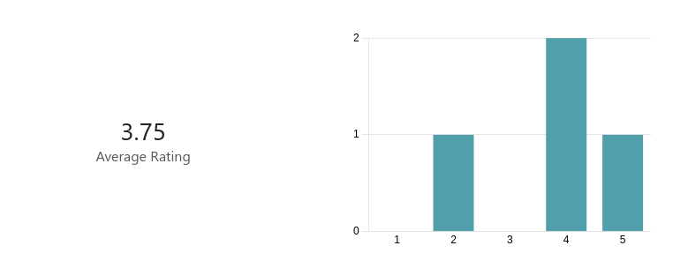

#### 16. Explain your rating to the previous question

|  |  |
| --- | --- |
| 1 | Cartoony graphics provide an imersive experience without needing to look photo-realistic. |
| 2 | Too cartoony for me |
| 3 | Extremely nice game aesthetics. I particularly enjoy the 3 areas the game cycles through: the beach, the caves and the badlands which makes the game enjoyable. Sound effects of the bike and character are very entertaining and fit in perfectly. Animation of the bike as you are pressing the WASD is very smooth. |
| 4 | Great visuals. Might be problematic on slow hardware. |

#### 17. Rate the aesthetics of Mountain Biking 1.0

#### 



#### 18. Explain your rating to the previous question

|  |  |
| --- | --- |
| 1 | I like the pixel art asthetic |
| 2 | Looks great. |
| 3 | Extremely simple with no animation, but as I have mentioned above, there is potential with the blocky theme of the game and I really like how the terrain looks. |
| 4 | Simple and unfinished. |

#### 19. Did you like the infinitely scrolling nature of the Dino Game and Moto 3XM?

#### 



#### 20. Rank the games on how much you liked them overall

#### 



#### 21. Explain your ranking

|  |  |
| --- | --- |
| 1 | I liked the moto 3XM games controls and the fact it was infinitly scrolling. I didnt like how boring the dino game became. |
| 2 | Dino game had best difficulty progression |
| 3 | Moto 3XM is definitely a game I can play start to finish as it fairly simple and provides different challenges, like going through boulders that are launched at you by some explosives and driving over rotating spikes. The Dino Game is very simplistic, which is okay, but it's not a game you could come back to every once in a while. Mountain Biking 1.0 is last due to it's controls and overall functionality. Controls are simple but do not conform to every level, such as jumping up to platform that is too high. |
| 4 | The dino game had the most going for it for such a simple game |

#### 22. Name 3 things you liked about the Dino Game

|  |  |
| --- | --- |
| 1 | The simple controls. How the difficulty increases overtime with speed. The pixel graphics |
| 2 | Difficulty progression. Pixel art Easy controls |
| 3 | Simplistic presentation. The change in background from night to day after a period of time. The repetitive nature of beating your old high score. |
| 4 | Visuals Accessible controls Progression |

#### 23. Name 3 things you liked about Moto 3XM

|  |  |
| --- | --- |
| 1 | The controls. The scrolling. The sound effects. |
| 2 | Controls Level Design Animations used |
| 3 | I like how the challenges are not repetitive. It delivered exactly what I expected. A relaxing, not difficult experience which was very enjoyable. I enjoyed the -0.5 seconds for a flip (implements a higher risk, higher reward game mechanic) I also liked the progression the levels take through the three different areas. |
| 4 | Fast paced nature Levels provided some change in difficulty Racing against the clock |

#### 24. Name 3 things you liked about Mountain Biking 1.0

|  |  |
| --- | --- |
| 1 | The graphics. The simple level design. The upgrades. |
| 2 | Graphics Levelling up Ease of play |
| 3 | I enjoyed the overall style the game went for, which blocky and has a lot of potential. I also like how the hitbox of the bike interacts with the hitbox of the environment vertically, allowing you to jump up walls. I like how it introduces different challenges, like the sky being deadly, adding a bit more variety, as every level is different. not part of this response: if anything in the whole feedback form is unclear, please let me know and I will do my best to expand on it :) |